1. Before Insertion

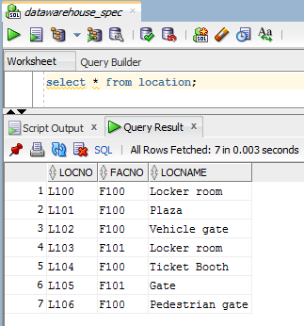

2. Insertion

INSERT INTO Location (LocNo, FacNo, LocName)

VALUES ('L107','F104','Door');

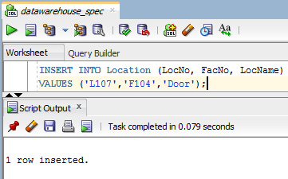

3. After Insertion

